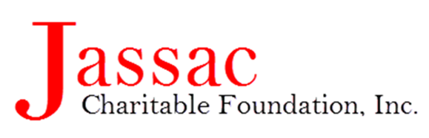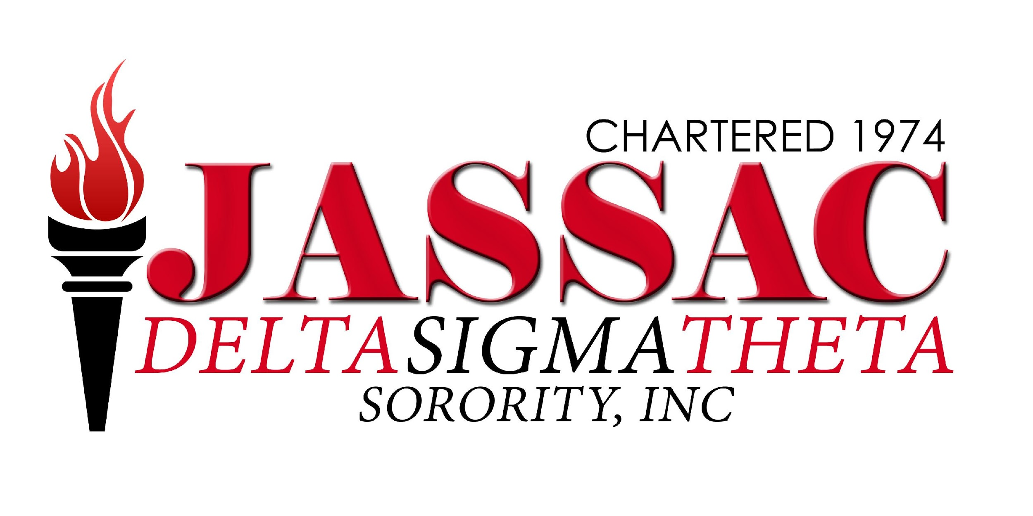
Countdown to 2018 – “A Night of Sheer Elegance” New Year’s Eve Gala Sponsorship Packages

Jassac Charitable Foundation, Inc. (Foundation) and the Joliet Area/South Suburban Alumnae Chapter of Delta Sigma Theta Sorority, Incorporated (JASSAC), are excited to host our Countdown to 2018 – “A Night of Sheer Elegance” New Year’s Eve Gala. Our event will be held on December 31, 2017 at Elements Conference Center in Orland Park, IL. We are inviting you to participate as a Sponsor in this very special event.
JASSAC was founded in 1974, by 17 dynamic women and today has more than 400 members. In 2003, the Foundation was established as an Illinois non-profit corporation. The primary purpose of the Foundation is to support programs that enhance the cultural, educational, and economic needs in the southern suburbs of Chicago, IL. These programs enrich the lives of youth through scholarships, mentoring, tutoring programs, and promoting community awareness of mental and physical health concerns.
As a Sponsor of the New Year’s Eve Gala, not only will you be assisting college-bound students achieve their educational goals and supporting community programming, but your business and/or service will be recognized by a highly-targeted group of consumers by way of social media, website, communications sent by our organization, signage, printed materials and verbal recognition. You will receive this marketing exposure prior to, and throughout the gala.
It is our hope that we can count on your support.
Sponsorship Levels and Benefits
- Platinum Level Sponsors $5,000.00
- Gold Level Sponsors $2,500.00
- Silver Level Sponsors $ 1,000.00
- Bronze Level Sponsors $ 500.00
- NYE 2018 Countdown Sponsor $ 100.00

Sponsorship Package Details

Platinum Level ($5,000)
- Full (100%) Program Page for Silent Auction for greeting or advertising and listed in the program as a Platinum Level Sponsor
- Company name and/or logo listed as Platinum Level Sponsor on signage displayed in registration, dinner area and Silent Auction
- Company name and or logo listed on NYE Gala Web site with a link to company site

- Company recognition on social media outlets (i.e. JASSAC Facebook Page)
- Company name announced verbally at NYE Gala as a Platinum Level Sponsor
- VIP Table in front of the room with 8 NYE Gala tickets

Gold Level ($2,500)
- Half (50%) Program Page for Silent Auction for greeting or advertising and listed in the program as a Gold Level Sponsor
- Company name and/or logo listed as a Gold Level Sponsor on signage displayed in registration, dinner area and Silent Auction
- Company name and/ or logo listed on NYE Gala Web site with a link to company site
- Company recognition on social media outlets (i.e. JASSAC Facebook Page)
- Company name announced verbally at the NYE Gala as a Gold Level Sponsor
- VIP Table in front of the room with 4 NYE Gala tickets

Silver Level (1,000)
- Quarter (25%) Program Page for Silent Auction for greeting or advertising and listed in the program as a Silver Level Sponsor
- Company name and/or logo listed as a Silver Level Sponsor on signage display in registration, dinner area and Silent Auction
- Company name listed on NYE Gala Web site with a link to the company site
- Company name announced verbally at NYE Gala as a Silver Level Sponsor
- VIP Table in front of the room with 2 NYE Gala tickets

Bronze Level ($500)
- Company name and/or log0 listed as a Bronze Level Sponsor on signage display in registration area
- Company name announced verbally at NYE Gala as a Bronze Level Sponsor
- VIP Table in front of room with 1 NYE Gala ticket

NYE 2018 Countdown Sponsor ($100)

- Recognition at the NYE Gala as a Sponsor
Please fill out the attached sponsorship commitment form and return no later than December 1, 2017. We are a 501(c) 3 tax-exempt non-profit organization. Your gift is tax-deductible to the fullest extent of the law.
If you have any questions or comments, please do not hesitate to email us directly at NYE2018@jassacdeltas.org.
Thank you in advance for your support!
With Warm Regards,

Helen Hill-Neely Kimberly Rowe-Barney
President, Jassac Charitable Foundation, Inc. President, Joliet Area/South Suburban Alumnae Chapter
Delta Sigma Theta Sorority, Inc.

Jassac Charitable Foundation, Incorporated
Countdown to 2018 – “A Night of Sheer Elegance” New Year’s Eve Gala
SPONSORSHIP COMMITMENT FORM
Deadline for Sponsorship: December 1, 2017

Sponsoring Company Name: ______________________________________________________
Name of Contact at Company: _____________________________________________________
Title of Contact: _________________________________________________________________
Address: ________________________________________________________________________________
City/State/Zip: ___________________________________________________________________
Phone: ______________________ __ Fax: _______________________ _______
E-mail:_______________________________ Web Address: _________________________
Sponsorship Level (please check one)
___ Platinum ($5,000) ___Gold ($2,500) ___ Silver ($1,000) ___ Bronze ($500)
___NYE 2018 Countdown ($100) ___ Donor (write in amount)

_____________________________________________________________________ _
Registration/Payment Options:
- Eventbrite https://jassacdeltasgala.eventbrite.com/

- By mail:
Please make checks payable to:
Jassac Charitable Foundation
19710 Governors Highway Suite 1, Flossmoor, Illinois 60422
- *Note: Please indicate “NYE Gala”-mailed to NYE2018@jassacdeltas.org for inclusion in the program and signage. All electronic files and ads are due no later than December 1, 2017.

