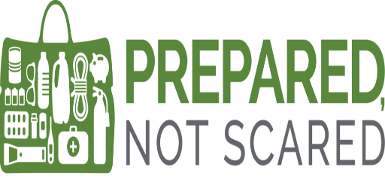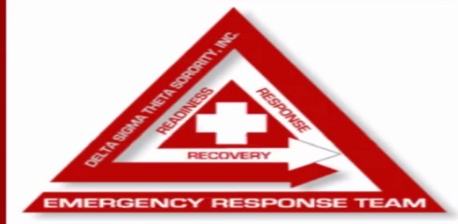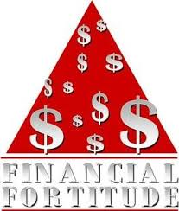
“Be Prepared, Not Scared!”
JASSAC Emergency Response Team & Economic Development wants you to have a Happy and Safe Halloween!

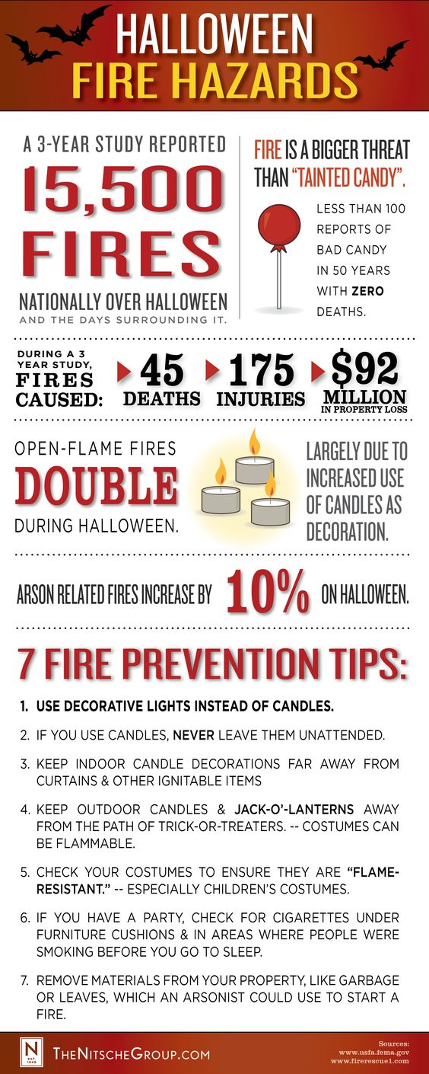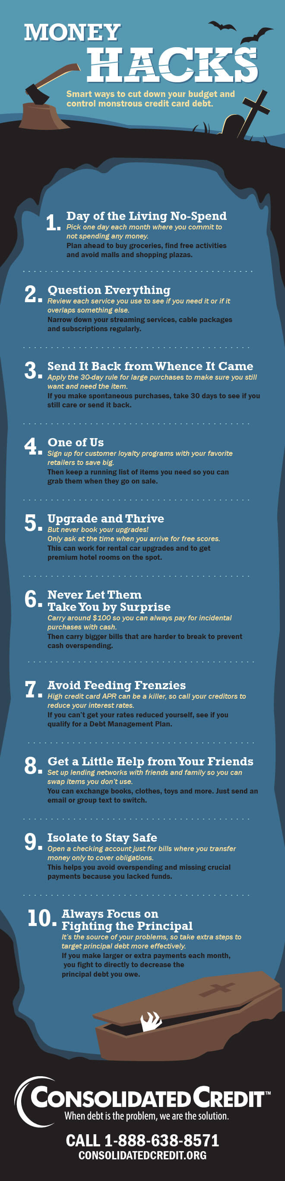
Submitted by Emergency Response Team & Economic Development
ERT Co-Chairs Samantha Jacobs & Cassandra Burrell-Harbin
Econ Dev Co-Chairs Kim Rowe-Barney & Kiana Williams

